Step 2: Drag and drop to take a first look

Create a view

You set out to identify key areas for improvement, but where to start? With four years' worth of data, you decide to drill into the overall sales data to see what you find. Start by creating a simple chart.

Learn more: Terms in this section

Learn more: Tableau workspace controls and elements

1. From the **Data** pane, drag **Order Date** to the **Columns** shelf.

**Note:** When you drag **Order Date** to the **Columns** shelf, Tableau creates a column for each year in your data set. Under each column is an **Abc** indicator. This indicates that you can drag text or numerical data here, like what you might see in an Excel spreadsheet. If you were to drag **Sales** to this area, Tableau creates a crosstab (like a spreadsheet) and displays the sales totals for each year.

1. From the **Data** pane, drag **Sales** to the **Rows** shelf.

Tableau generates the following chart with sales rolled up as a sum (aggregated). You can see total aggregated sales for each year by order date.

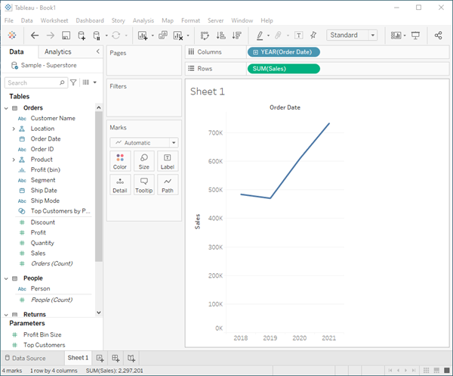

*When you first create a view that includes time (in this case Order Date), Tableau automatically generates a line chart.*

This line chart shows that sales look pretty good and seem to be increasing over time. This is good information, but it doesn't really tell you much about which products have the strongest sales and if there are some products that might be performing better than others. Since you just got started, you decide to explore further and see what else you can find out.

Learn more: Explore your options

Check your work! Watch "Create a view" in action

*Click the image to replay it.*



Refine your view

To gain more insight into which products drive overall sales, try adding more data. Start by adding the product categories to look at sales totals in a different way.

1. From the **Data** pane, drag **Category** to the **Columns** shelf and place it to the right of YEAR(Order Date).

Your view updates to a bar chart. By adding a second discrete dimension to the view you can categorize your data into discrete chunks instead of looking at your data continuously over time. This creates a bar chart and shows you overall sales for each product category by year.

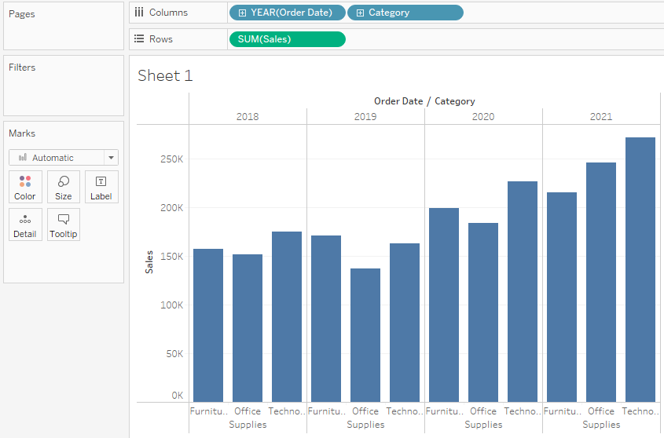

Learn more: Show me the numbers

Learn more: Change your perspective

Your view is doing a great job showing sales by category—furniture, office supplies, and technology. An interesting insight is revealed!

From this view, you can see that sales for furniture is growing faster than sales for office supplies, even though Office Supplies had a really good year in 2021. Perhaps you can recommend that your company focus sales efforts on furniture instead of office supplies? Your company sells a lot of different products in those categories, so you'll need more information before you can make a recommendation.

To help answer that question, you decide to look at products by sub-category to see which items are the big sellers. For example, for the Furniture category, you want to see details about bookcases, chairs, furnishings, and tables. Looking at this data might help you gain insights into sales and later on, overall profitability, so add sub-categories to your bar chart.

1. Double-click or drag **Sub-Category** to the **Columns** shelf.

**Note:** You can drag and drop or double-click a field to add it to your view, but be careful. Tableau makes assumptions about where to add that data, and it might not be placed where you expect. You can always click **Undo** to remove the field, or drag it off the area where Tableau placed it to start over.

Sub-Category is another discrete field. It creates another header at the bottom of the view, and shows a bar for each sub-category (68 marks) broken down by category and year.

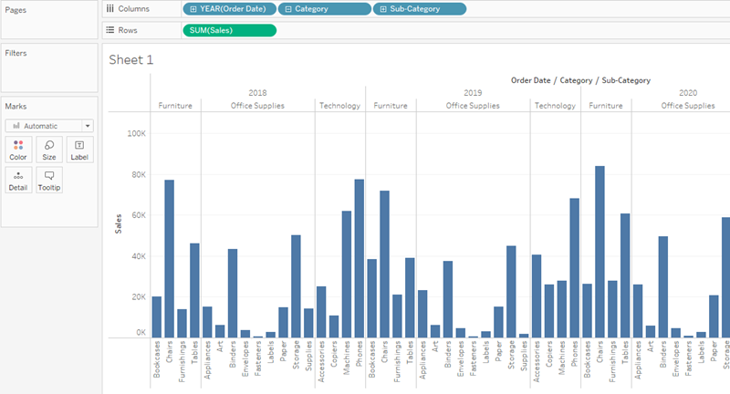

Now you are getting somewhere, but this is a lot of data to visually sort through. In the next section, you will learn how you can add color, filters, and more to focus on specific results.

Learn more: Use a different view to compare product sales

Check your work! Watch "Refine your view" in action

*Click the image to replay it*



Step summary

This step was all about getting to know your data and starting to ask questions about your data to gain insights. You learned how to:

* Create a chart in a view that works for you.
* Add fields to get the right level of detail in your view.

Now you're ready to begin focusing on your results to identify more specific areas of concern. In the next section, you will learn how to use filters and colors to help you explore your data visually.

Step 3: Focus your results

You've created a view of product sales broken down by category and sub-category. You are starting to get somewhere, but that is a lot of data to sort through. You need to easily find the interesting data points and focus on specific results. Well, Tableau has some great options for that!

Filters and colors are ways you can add more focus to the details that interest you. After you add focus to your data, you can begin to use other Tableau Desktop features to interact with that data.

Add filters to your view

You can use filters to include or exclude values in your view. In this example, you decide to add two simple filters to your worksheet to make it easier to look at product sales by sub-category for a specific year.

1. In the **Data** pane, right-click **Order Date** and select **Show Filter**.
2. Repeat the step above for the **Sub-Category** field.

The filters are added to the right side of your view in the order that you selected them. Filters are card types and can be moved around on the canvas by clicking on the filter and dragging it to another location in the view. As you drag the filter, a line appears that shows you where you can drop the filter to move it.

**Note**: The Get Started tutorial uses the default position of the filter cards.

**More on Filtering** in the Learning Library (in the top menu).

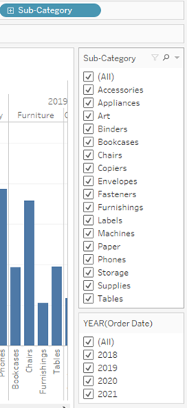

Check your work! Watch "Apply filters to your view" in action

*Click the image to replay it*



Add color to your view

Adding filters helps you to sort through all of this data—but wow, that’s a lot of blue! It's time to do something about that.

Currently, you are looking at sales totals for your various products. You can see that some products have consistently low sales, and some products might be good candidates for reducing sales efforts for those product lines. But what does overall profitability look like for your different products? Drag **Profit** to color to see what happens.

From the **Data** pane, drag **Profit** to **Color** on the Marks card.

By dragging profit to color, you now see that you have negative profit in Tables, Bookcases, and even Machines. Another insight is revealed!

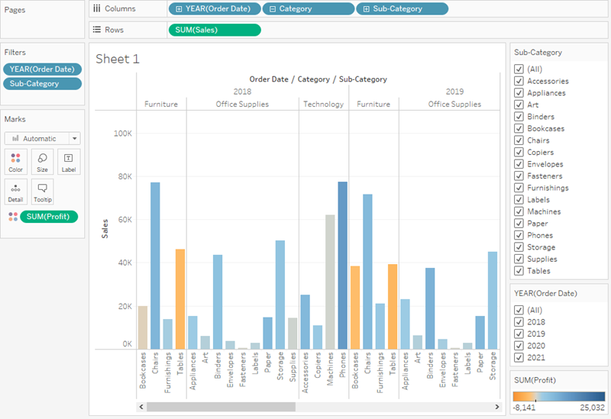

**Note:** Tableau automatically added a color legend and assigned a diverging color palette because your data includes both negative and positive values.

Learn more: Working with color

Check your work! Watch "Add color to your view" in action

*Click the image to replay it*



Find key insights

As you've learned, you can explore your data as you build views with Tableau Desktop. Adding filters and colors helps you better visualize your data and can identify problems right away.

The next step is to interact with your view so that you can begin drawing conclusions.

Looking at your view, you saw that you had some unprofitable products, but now you want to see if these products have been unprofitable year over year.

It's time to use your filters to take a closer look.

1. In the view, in the **Sub-Category** filter card, clear all of the check boxes except **Bookcases**, **Machines**, and **Tables**.

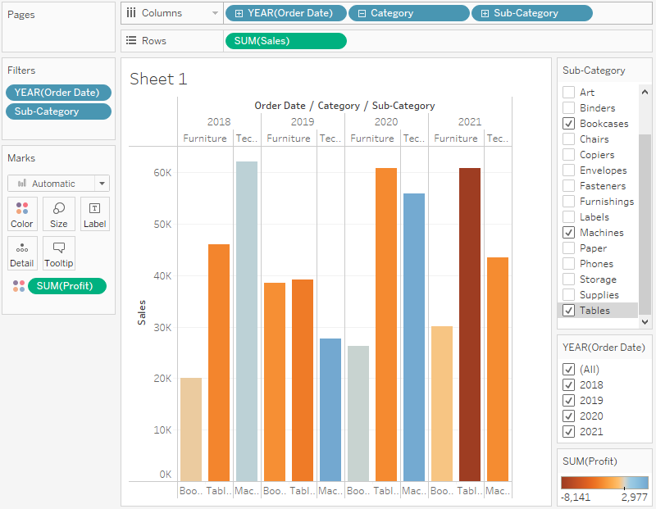

Now you can see that, in some years, Bookcases and Machines were profitable. However, recently Machines are unprofitable. While you've made an important discovery, you want to gather more information before proposing any action items to your boss.

On a hunch, you decide to break up your view by region:

1. Select **All** in the **Sub-Category** filter card to show all sub-categories again.
2. From the **Data** pane, drag **Region** to the **Rows** shelf and place it to the left of Sum(Sales).

Tableau creates a view with multiple axes broken down by region.

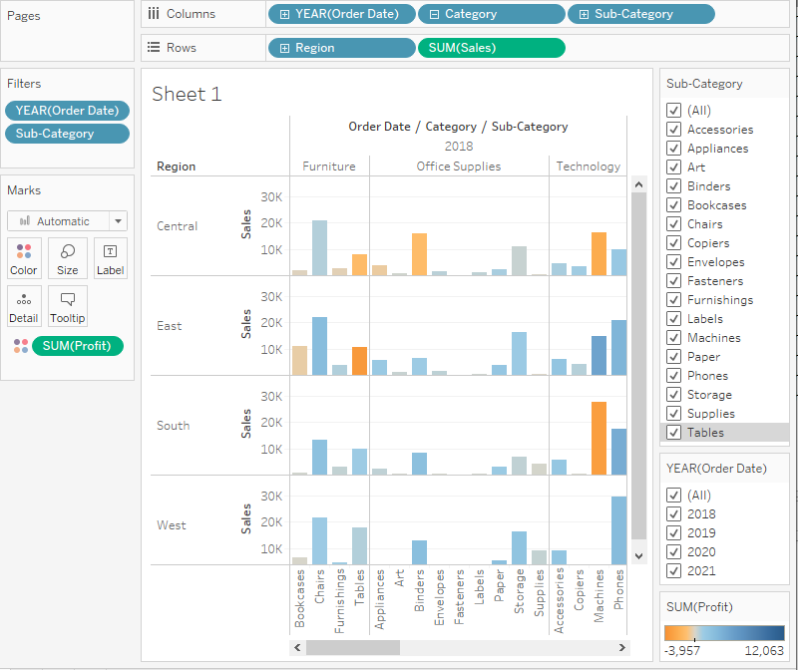

Now you see sales and profitability by product for each region. By adding region to the view and filtering the Sub-Category for Machines only, you notice that machines in the South are reporting a higher negative profit overall than in your other regions. You've discovered a hidden insight!

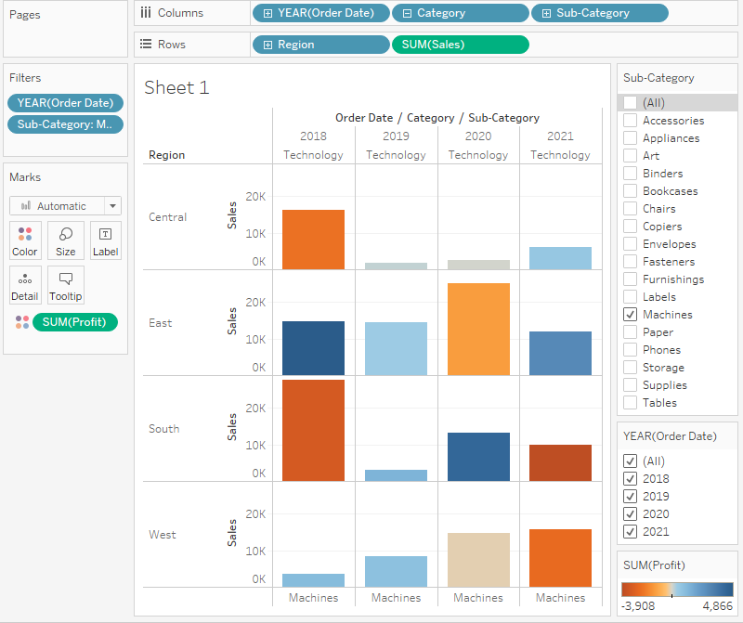

This view best encapsulates your work so far. Select **All** in the **Sub-Category** filter card (if you changed your filter) to show all sub-categories again, name the worksheet, and add a title.

1. At the bottom-left of the workspace, double-click **Sheet 1** and type **Sales by Product/Region**.

You choose to focus your analysis on the South, but you don't want to lose the view you've created. In Tableau Desktop, you can duplicate your worksheet to continue where you left off.

1. In your workbook, right-click the **Sales by Product/Region** sheet and select **Duplicate**.
2. Rename the duplicated sheet to **Sales in the South**.
3. In your new worksheet, from the **Data** pane, drag **Region** to the **Filters** shelf to add it as a filter in the view.
4. In the Filter Region dialog box, clear all check boxes except **South** and then click **OK**.

Your view updates to look like the image below.

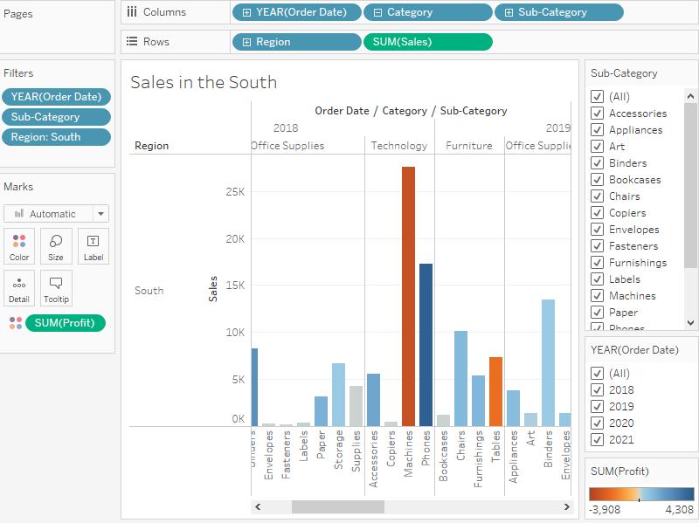

Now you can focus on sales and profit in the South. You immediately see that machine sales had negative profit in 2018 and again in 2021. This is definitely something to investigate!

1. Save your work by selecting **File** > **Save As**. Give your workbook a name, such as Regional Sales and Profits.

Learn more: How Tableau organizes your saved workbooks

Check your work! Watch "Find key insights" in action below

*Click the image to replay it*



Step summary

In this step you used filter and color to make working with your data a bit easier. You also learned about a few fun features that Tableau offers to help you answer key questions about your data. You learned how to:

* Apply filters and color to make it easier to focus on the areas of your data that interest you the most.
* Interact with your chart using the tools that Tableau provides.
* Duplicate worksheets and save your changes to continue exploring your data in different ways without losing your work.

Having explored your data in Tableau Desktop, you've identified areas of concern. You know sales and profit in the South are a problem, but you don't yet have a solution. You want to look at other factors that might be contributing to these results. Next, you'll leverage another key feature in Tableau to work with geographic data.

Step 4: Explore your data geographically

You've built a great view that allows you to review sales and profits by product over several years. And after looking at product sales and profitability in the South, you decide to look for trends or patterns in that region.

Because you're looking at geographic data (the Region field), you have the option to build a map view. Map views are great for displaying and analyzing this kind of information. Plus, they're just cool!

For this example, Tableau has already assigned the proper geographic roles to the Country, State, City, and Postal Code fields. That's because it recognized that each of those fields contained geographic data. You can get to work creating your map view right away.

Learn more: Meet geographic roles

Build a map view

Start fresh with a new worksheet.

1. Click the **New worksheet** icon at the bottom of the workspace.

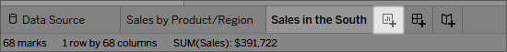

Tableau keeps your previous worksheet and creates a new one so that you can continue exploring your data without losing your work.

1. In the **Data** pane, double-click **State** to add it to **Detail** on the Marks card.

Now you’ve got a map view!

*Click the image to replay it*



Learn more: Double-click to add geographic fields

Because Tableau already knows that state names are geographic data and because the State dimension is assigned the State/Province geographic role, Tableau automatically creates a map view.

There is a mark for each of the 48 contiguous states in your data source. (Sadly, Alaska and Hawaii aren't included in your data source, so they are not mapped.)

Notice that the Country field is also added to the view. This happens because the geographic fields in Sample - Superstore are part of a hierarchy. Each level in the hierarchy is added as a level of detail.

Additionally, Latitude and Longitude fields are added to the Columns and Rows shelves. You can think of these as X and Y fields. They're essential any time you want to create a map view, because each location in your data is assigned a latitudinal and longitudinal value. Sometimes the Latitude and Longitude fields are generated by Tableau. Other times, you might have to manually include them in your data. You can find resources to learn more about this in the Learning Library.

Now, having a cool map focused on 48 states is one thing, but you wanted to see what was happening in the South, remember?

1. Drag **Region** to the **Filters** shelf, and then filter down to the **South** only. The map view zooms in to the South region, and there is a mark for each state (11 total).

Now you want to see more detailed data for this region, so you start to drag other fields to the Marks card:

1. Drag the **Sales** measure to **Color** on the Marks card.

*Click the image to replay it*



The view automatically updates to a filled map, and colors each state based on its total sales. Because you're exploring product sales, you want your sales to appear in USD. Click the **Sum(Sales)** field on the **Columns** shelf, and select **Format**. For Numbers, select **Currency**.

Any time you add a continuous measure that contains positive numbers (like Sales) to Color on the Marks card, your filled map is colored blue. Negative values are assigned orange.

Sometimes you might not want your map to be blue. Maybe you prefer green, or your data isn’t something that should be represented with the color blue, like wildfires or traffic jams. That would just be confusing!

No need to worry, you can change the color palette just like you did before.

1. Click **Color** on the Marks card and select **Edit Colors**.

For this example, you want to see which states are doing well, and which states are doing poorly in sales.

1. In the Palette drop-down list, select **Red-Green Diverging** and click **OK**. This allows you to see quickly the low performers and the high performers.

Your view updates to look like this:

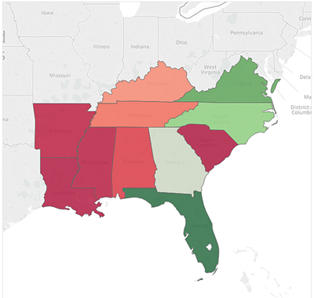

But wait. Everything just went red! What happened?

The data is accurate, and *technically* you can compare low performers with high performers, but is that really the whole story?

Are sales in some of those states really that terrible, or are there just more people in Florida who want to buy your products? Maybe you have smaller or fewer stores in the states that appear red. Or maybe there’s a higher population density in the states that appear green, so there are just more people to buy your stuff.

Either way, there’s no way you want to show this view to your boss because you aren't confident the data is telling a useful story.

1. Click the **Undo** icon  in the toolbar to return to that nice, blue view.

There’s still a color problem. Everything looks dandy—that’s the problem!

At first glance, it appears that Florida is performing the best. Hovering over its mark reveals a total of 89,474 USD in sales, as compared to South Carolina, for example, which has only 8,482 USD in sales. However, have any of the states in the South been profitable?

1. Drag **Profit** to **Color** on the Marks card to see if you can answer this question.

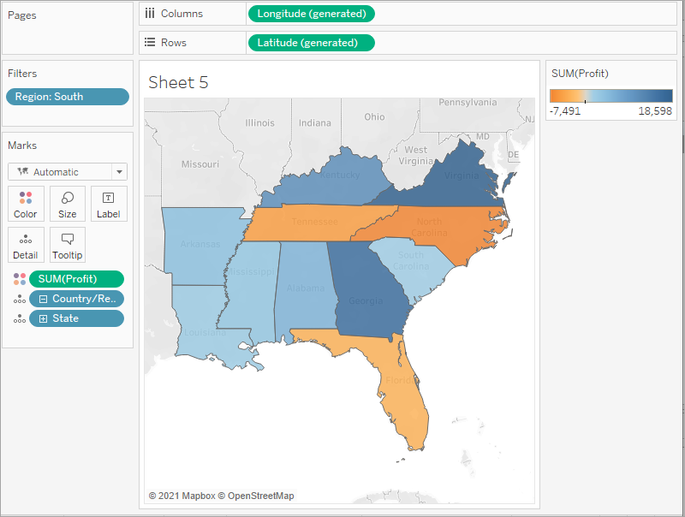

Now that’s better! Because profit often consists of both positive and negative values, Tableau automatically selects the Orange-Blue Diverging color palette to quickly show the states with negative profit and the states with positive profit.

It’s now clear that Tennessee, North Carolina, and Florida have negative profit, even though it appeared they were doing okay—even great—in Sales. But why? You'll answer that in the next step.

Check your work! Watch "Build a map view" in action

*Click the image to replay it*



Step 5: Drill down into the details

In the last step you discovered that Tennessee, North Carolina, and Florida have negative profit. To find out why, you decide to drill down even further and focus on what's happening in those three states alone.

Pick up where your map view left off

As you saw in the last step, maps are great for visualizing your data broadly. A bar chart will help you get into the nitty-gritty. To do this, you create another worksheet.

1. Double-click **Sheet 3** and name the worksheet **Profit Map**.
2. Right-click **Profit Map** at the bottom of the workspace and select **Duplicate**. Name the new sheet **Negative Profit Bar Chart**.
3. In the Negative Profit Bar Chart worksheet, click **Show Me**, and then select **horizontal bars**.

Show Me highlights different chart types based on the data you've added to your view.

**Note:** At any time, you can click **Show Me** again to collapse it.

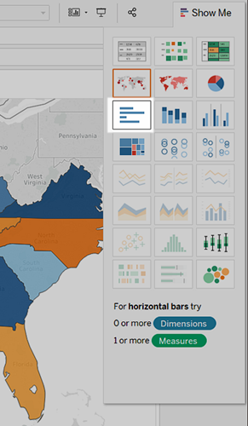

You now have a bar chart again—just like that.

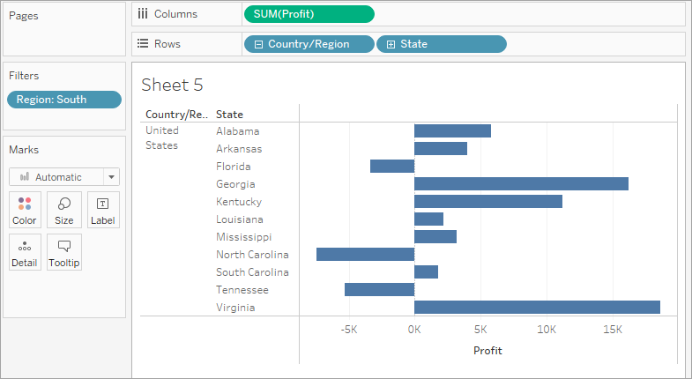

1. To select multiple bars on the left, click and drag your cursor across the bars between **Tennessee**, **North Carolina**, and **Florida**. On the tooltip that appears, select **Keep Only** to focus on those three states.

**Note:** You can also right-click one of the highlighted bars, and select **Keep Only**.

Notice that an *Inclusions* field for State is added to the **Filters** shelf to indicate that certain states are filtered from the view. The icon with two circles on the field indicates that this field is a set. You can edit this field by right-clicking the field on the **Filters** shelf and selecting, **Edit Filter**.

Now you want to look at the data for the cities in these states.

1. On the **Rows** shelf, click the **plus** icon on the **State** field to drill-down to the City level of detail.

There’s almost too much information here, so you decide to filter the view down to the cities with the most negative profit by using a Top N Filter.

Check your work! Watch steps 1-5 in action

*Click the image to replay it*



Create a Top N Filter

You can use a Top N Filter in Tableau Desktop to limit the number of marks displayed in your view. In this case, you want to use the Top N Filter to hone in on poor performers.

1. From the Data pane, drag **City** to the **Filters** shelf.
2. In the Filter dialog box, select the **Top** tab, and then do the following:
   1. Click **By field**.
   2. Click the **Top** drop-down and select **Bottom** to reveal the poorest performers.
   3. Type **5** in the text box to show the bottom 5 performers in your data set.

Tableau Desktop has already selected a field (Profit) and aggregation (Sum) for the Top N Filter based on the fields in your view. These settings ensure that your view will display only the five poorest performing cities by sum of profit.

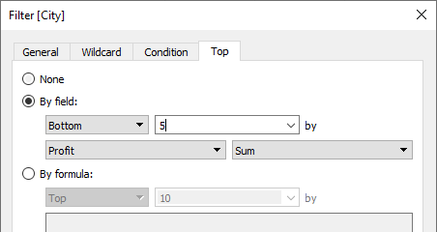

* 1. Click **OK**.

What happened to the bar chart, and why is it blank? That's a great question, and a great opportunity to introduce the Tableau Order of Operations.

The Tableau Order of Operations, also known as the query pipeline, is the order that Tableau performs various actions, such as the order in which it applies your filters to the view.

Tableau applies filters in the following order:

* 1. Extract Filters
  2. Data Source Filters
  3. Context Filters
  4. Top N Filters
  5. Dimension Filters
  6. Measure Filters

The order that you create filters in, or arrange them on the **Filters** shelf, doesn't change the order in which Tableau applies those filters to your view.

The good news is you can tell Tableau to change this order when you notice something strange happening with the filters in your view. In this example, the Top N Filter is applied to the five poorest performing cities by sum of profit for the whole map, but none of those cities are in the South, so the chart is blank.

To fix the chart, add a filter to context. This tells Tableau to filter that field first, regardless of where it falls on the order of operations.

But which field do you add to context? There are three fields on the **Filters** shelf: Region (a dimension filter), City (a top N filter), and *Inclusions (Country, State) (Country, State)* (a set).

If you look at the order of operations again, you know that the set and the top N filter are being applied before the dimension filter. But do you know if the top N filter or the set filter is being applied first? Let's find out.

1. On the **Filters** shelf, right-click the **City** field and select **Add to Context**.

The City field turns gray and moves to the top of the **Filters** shelf, but nothing changes in the view. So even though you're forcing Tableau to filter City first, the issue isn't resolved.

1. Click **Undo**.
2. On the **Filters** shelf, right-click the ***Inclusions (Country, State) (Country, State)*** set and select **Add to Context**.

The *Inclusions (Country, State) (Country, State)* set turns gray and moves to the top of the **Filters** shelf. And bars have returned to your view!

You're on to something! But there are six cities in the view, including Jacksonville, North Carolina, which has a positive profit. Why would a city with a positive profit show up in the view when you created a filter that was supposed to filter out profitable cities?

Jacksonville, North Carolina is included because City is the lowest level of detail shown in the view. For Tableau Desktop to know the difference between Jacksonville, North Carolina, and Jacksonville, Florida, you need to drill down to the next level of detail in the location hierarchy, which, in this case, is Postal Code. After you add Postal Code, you can exclude Jacksonville in North Carolina without also excluding Jacksonville in Florida.

1. On the **Rows** shelf, click the plus icon on **City** to drill down to the Postal Code level of detail.
2. Right-click the postal code for Jacksonville, North Carolina, **28540**, and then select **Exclude**.

Postal Code is added to the **Filters** shelf to indicate that certain members in the Postal Code field have been filtered from the view. Even when you remove the Postal Code field from the view, the filter remains.

1. Drag **Postal Code** off the **Rows** shelf.

Your view updates to look like this:

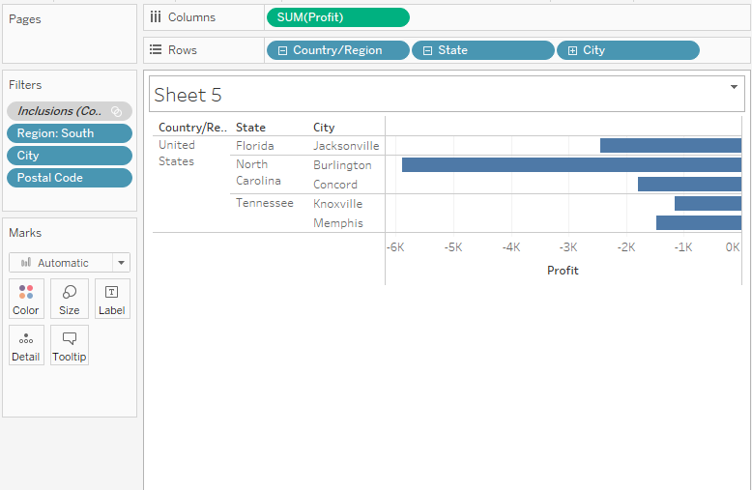

Check your work! Watch steps 1-8 in action

*Click the image to replay it*



Now that you've focused your view to the least profitable cities, you can investigate further to identify the products responsible.

Identify the troublemakers

You decide to break up the view by Sub-Category to identify the products dragging profit down. You know that the Sub-Category field contains information about products sold by location, so you start there.

1. Drag **Sub-Category** to the **Rows** shelf, and place it to the right of City.
2. Drag **Profit** to **Color** on the Marks card to make it easier to see which products have negative profit.
3. In the Data pane, right-click **Order Date** and select **Show Filter**.

You can now explore negative profits for each year if you want, and quickly spot the products that are losing money.

Machines, tables, and binders don’t seem to be doing well. So what if you stop selling those items in Jacksonville, Concord, Burlington, Knoxville, and Memphis?

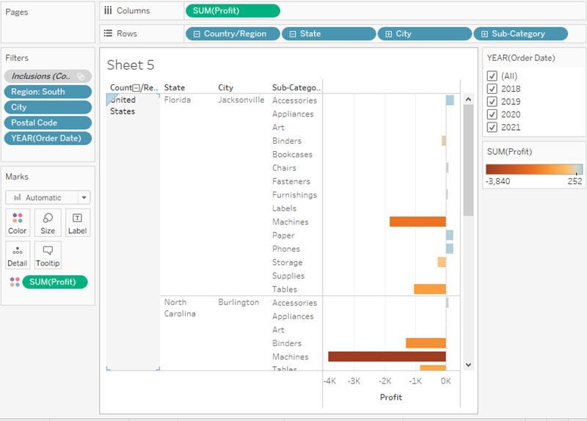

Verify your findings

Will eliminating binders, machines, and tables improve profits in Florida, North Carolina, and Tennessee? To find out, you can filter out the problem products to see what happens.

1. Go back to your map view by clicking the **Profit Map** sheet tab.
2. In the Data pane, right-click **Sub-Category** and select **Show Filter**.

A filter card for all of the products you offer appears next to the map view. You'll use this filter later.

1. From the Data pane, drag **Profit** and **Profit Ratio** to **Label** on the Marks card. To format the Profit Ratio as a percentage, right-click **Profit Ratio**, and select **Format**. Then, for **Default Numbers**, choose **Percentage** and set the number of decimal places you want displayed on the map. For this map, we'll choose zero decimal places.

Now you can see the exact profit of each state without having to hover your cursor over them.

1. In the Data pane, right-click **Order Date** and select **Show Filter** to provide some context for the view.

A filter card for YEAR(Order Date) appears in the view. You can now view profit for all years or for a combination of years. This might be useful for your presentation.

1. Clear **Binders**, **Machines**, and **Tables** from the list on the Sub-Category filter card in the view.

Recall that adding filters to your view lets you include and exclude values to highlight certain parts of your data.

As you clear each member, the profit for Tennessee, North Carolina, and Florida improve, until finally, each has a positive profit.

*Click the image to replay it*



Hey, you made an interesting discovery!

Binders, machines, and tables are definitely responsible for the losses in Tennessee, North Carolina, and Florida, but not for the rest of the South. Do you notice how profit actually decreases for some of the other states as you clear items from the filter card? For example, if you toggle **Binders** on the Sub-Category filter card, profit drops by four percent in Arkansas. You can deduce that Binders are actually profitable in Arkansas.

You want to share this discovery with the team by walking them through the same steps you took.

1. Select **(All)** on the Sub-Category filter card to include all products again.

Learn more: More questions you could ask

Check your work! Watch "Verify your findings" in action

*Click the image to replay it*



Now you know that machines, tables, and binders are problematic products for your company. In focusing on the South, you see that these products have varying impacts on profit. This might be a worthwhile conversation to have with your boss.

Next, you'll assemble the work you've done so far in a dashboard so that you can clearly present your findings.

**More on working with maps and geographic roles** in the Learning Library (in the top menu).

Step 6: Build a dashboard to show your insights

You’ve created four worksheets, and they're communicating important information that your boss needs to know. Now you need a way to show the negative profits in Tennessee, North Carolina, and Florida and explain some of the reasons why profits are low.

To do this, you can use dashboards to display multiple worksheets at once, and—if you want—make them interact with one another.

Set up your dashboard

You want to emphasize that certain items sold in certain places are doing poorly. Your bar graph view of profit and your map view demonstrate this point nicely.

1. Click the **New dashboard** button.



1. In the **Dashboard** pane on the left, you'll see the sheets that you created. Drag **Sales in the South** to your empty dashboard.
2. Drag **Profit Map** to your dashboard, and drop it on top of the Sales in the South view.

Your view will update to look like this:

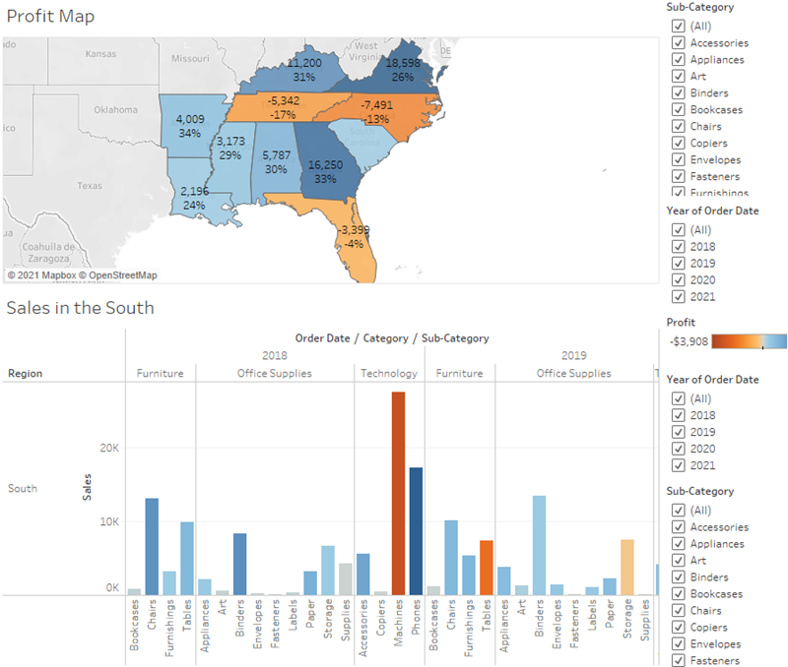

Now you can see both views at once!

But sadly, the bar chart is a bit squished, which isn’t helping your boss understand your data.

Arrange your dashboard

It's not easy to see details for each item under **Sub-Category** from your Sales in the South bar chart. Also, because we have the map in view, we probably don't need the **South region** column in Sales in the South, either.

Resolving these issues will give you more room to communicate the information you need.

1. On Sales in the South, right-click in the column area under the **Region** column header, and clear **Show header**.

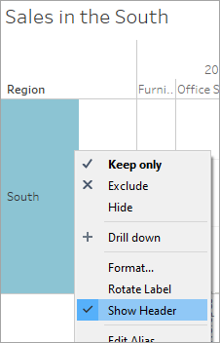

1. Repeat this process for the **Category** row header.

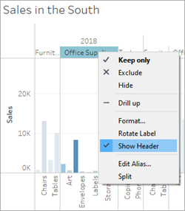

You've now hidden unnecessary columns and rows from your dashboard while preserving the breakdown of your data. The extra space makes it easier to see data on your dashboard, but let's freshen things up even more.

1. Right-click the **Profit Map** title and select **Hide Title**.

The title Profit Map is hidden from the dashboard and even more space is created.

1. Repeat this step for the **Sales in the South** view title.
2. Select the first **Sub-Category** filter card on the right side of your view, and at the top of the card, click the **Remove** icon .
3. Repeat this step for the second **Sub-Category** filter card and one of the **Year of Order Date** filter cards.
4. Click on the **Profit color legend** and drag it from the right to below Sales in the South.
5. Finally, select the remaining **Year of Order Date** filter, click its drop-down arrow, and then select **Floating**. Move it to the white space in the map view. In this example, it is placed just off the East Coast, in the Atlantic Ocean.

Try selecting different years on the Year of Order Date filter. Your data is quickly filtered to show that state performance varies year by year. That's nice, but it could be made even easier to compare.

1. Click the drop-down arrow at the top of the **Year of Order Date** filter, and select **Single Value (Slider)**.

Your view updates to look like this:

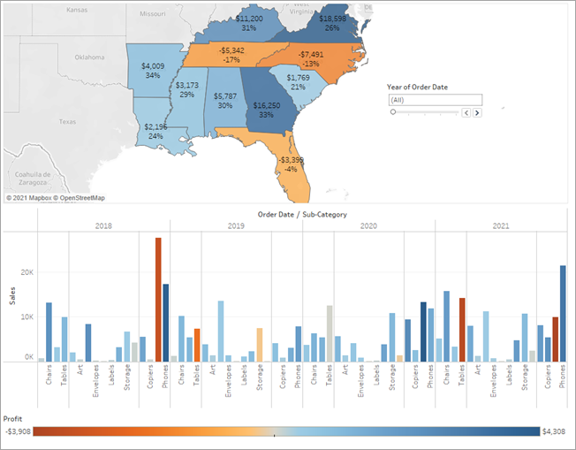

Learn more: Differentiate Floating vs. Tiled objects on a dashboard

Now your dashboard is looking really good! Now, you can easily compare profit and sales by year. But that’s not so different from a couple pictures in a presentation—and you're using Tableau! Let's make your dashboard more engaging.

Check your work! Watch "Arrange your dashboard" in action

*Click the image to replay it*



Add interactivity

Wouldn't it be great if you could view which sub-categories are profitable in specific states?

1. Select **Profit Map** in the dashboard, and click the **Use as filter** icon  in the upper right corner.
2. Select a state within the Southern region of the map.

The Sales in the South bar chart automatically updates to show just the sub-category sales in the selected state. You can quickly see which sub-categories are profitable.

1. Click an area of the map other than the colored Southern states to clear your selection.

You also want viewers to be able to see the change in profits based on the order date.

1. Select the **Year of Order Date** filter, click its drop-down arrow, and select **Apply to Worksheets** > **Selected Worksheets**.
2. In the Apply Filter to Worksheets dialog box, select **All in dashboard**, and then click **OK**.

This option tells Tableau to apply the filter to all worksheets in the dashboard that use this same data source.

Explore state performance by year with your new, interactive dashboard!

Check your work! Watch "Add interactivity" in action

Here, we filter Sales in the South to only items sold in North Carolina, and then explore year by year profit.

*Click the image to replay it*



Rename and go

You show your boss your dashboard, and she loves it. She's named it "Regional Sales and Profit," and you do the same by double-clicking the **Dashboard 1** tab and typing **Regional Sales and Profit**.

In her investigations, your boss also finds that the decision to introduce machines in the North Carolina market in 2021 was a *bad idea*.

Your boss is glad she has this dashboard to explore, but she also wants you to present a clear action plan to the larger team. She asks you to create a presentation with your findings.

Good thing you know about stories in Tableau.